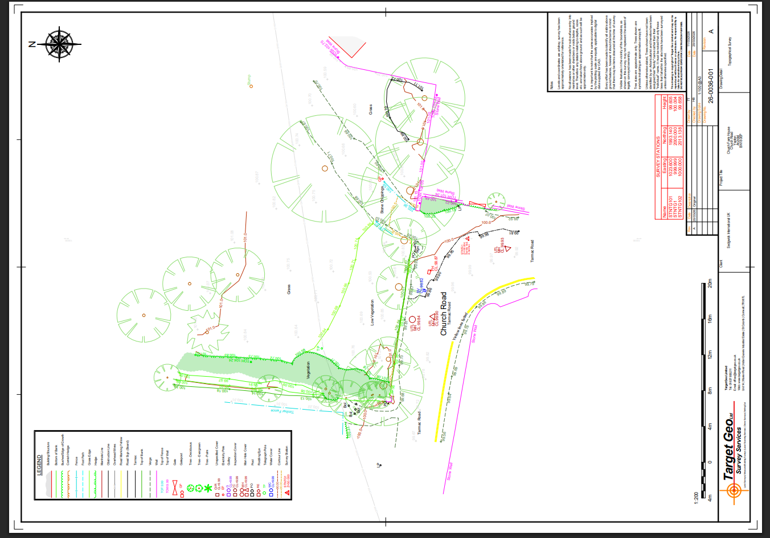
1 Lime tree fell in high winds early June 2026 since felled for highway safety reasons
3 Lime trees proposed to be felled

