We have been asked by the Free Holder Mr Brian Osment to do some work on trees within his property.
There is a single Lime tree that is listed not listed on the Preservation order, but is very near to T3 which has been heavily pollard last year and is in the garden of a neighbouring property. Which is marked on the map in pink.
This tree stands at 26m (bare leafed) we are preposing to reduce down to 20M
There is a 10m dead wood branch that falls within this section we wish to reduce. When brining down in hight we wish to create a balanced shape.
We then prepose to bring the north side from 7m into 6m
The east side from 10m into 7m
The south side 9m into 7m
The west side 10m to 7m
We also would like to uplift from the ground 4.5m
We would like to remove the substantial basal growth. Our intention is to balance out the tree.
The next trees in question are listed as G1 and are 19 lime trees with an emergency roadway through the middle. Originally there was 22 trees listed in G1 but on counting there is only 19 remaining.
I have created a table below listing all the trees that we have been asked to reduce in hight. Our intention is to bring all the trees down to a uniformed hight of 16.5m and bring each one into a balanced shape at the top so they do not appear ‘flat topped’ but keeping a natural shape.
At both the top entrance by Manor Lodge and at the other end by Walberton Park we would like to bring the trees in slightly so to create a more balanced uniformed shape as you enter the line of trees. All dimensions of each tree is listed in table below.
Any dead wood will be removed and basal growth removed and any epicormic growth up to 3m would also be removed.
Tree number | start height in Meters | reduce round to a balanced shape, aiming for hight in meters | N side reduction from in meters | N side after in meters | E side before in meters | E side after in meters | s side before in meters | S Side after in meters | W side before in meters | W side after in meters | uplift from ground to | notes - removal of all epicormic growth up to 3 m
T1 | 26 | 16.5 | 8 | 6.5 | 7 | 7 | 2 | 2 | 6 | 3 | 0 | shape round to create balanced form at the entrance to run of trees
T2 | 27 | 16.5 | 5 | 5 | 7 | 7 | 4 | 4 | 3 | 3 | 0
T3 | 27 | 16.5 | 5 | 5 | 6 | 6 | 4 | 4 | 3 | 3 | 0
T4 | 28 | 16.5 | 5 | 5 | 7 | 7 | 5 | 5 | 4 | 4 | 0
T5 | 28 | 16.5 | 5 | 5 | 6 | 6 | 6 | 6 | 5 | 5 | 0
T6 | 28.5 | 16.5 | 5 | 5 | 6 | 6 | 6 | 6 | 5 | 5 | 0
T7 | 28.5 | 16.5 | 6 | 6 | 8 | 8 | 6 | 6 | 4 | 4 | 7m | uplift over garage so not dragging on roof
T8 | 28 | 16.5 | 5 | 5 | 4 | 4 | 3 | 3 | 3 | 3 | 0
T9 | 23.5 | 16.5 | 6 | 6 | 8 | 6 | 7 | 6 | 6 | 6 | 0 | bring round to create a more balanced shape at the entrance to walk of trees
T10 | 23.5 | 16.5 | 4 | 4 | 7 | 6 | 7.5 | 6 | 8 | 7.5 | 0
T11 | 24 | 16.5 | 5 | 5 | 5 | 5 | 5 | 5 | 7 | 7 | 0
T12 | 24.5 | 16.5 | 5 | 5 | 5 | 5 | 5 | 5 | 7 | 7 | 0
T13 | 24.5 | 16.5 | 6 | 6 | 4 | 4 | 5 | 5 | 7 | 7 | 0 | significant dead wood in one section to north side of crown,
T14 | 23.5 | 16.5 | 5 | 5 | 4 | 4 | 4 | 4 | 8.5 | 8.5 | 0
T15 | 25 | 16.5 | 5 | 5 | 4 | 4 | 5 | 5 | 7.5 | 7.5 | 0
T16 | 26 | 16.5 | 5 | 5 | 4 | 4 | 5 | 5 | 7 | 7 | 0
T17 | 28 | 16.5 | 6 | 6 | 4 | 4 | 6 | 6 | 7.5 | 7.5 | 0 | major dead wood
T18 | 28 | 16.5 | 8 | 8 | 5 | 5 | 6 | 6 | 8 | 8 | 0
T19 | 24 | 16.5 | 8.5 | 6.5 | 5 | 5 | 6 | 6 | 9.5 | 7.5 | 0 | bring round to create a more balanced shape at the entrance to walk of trees
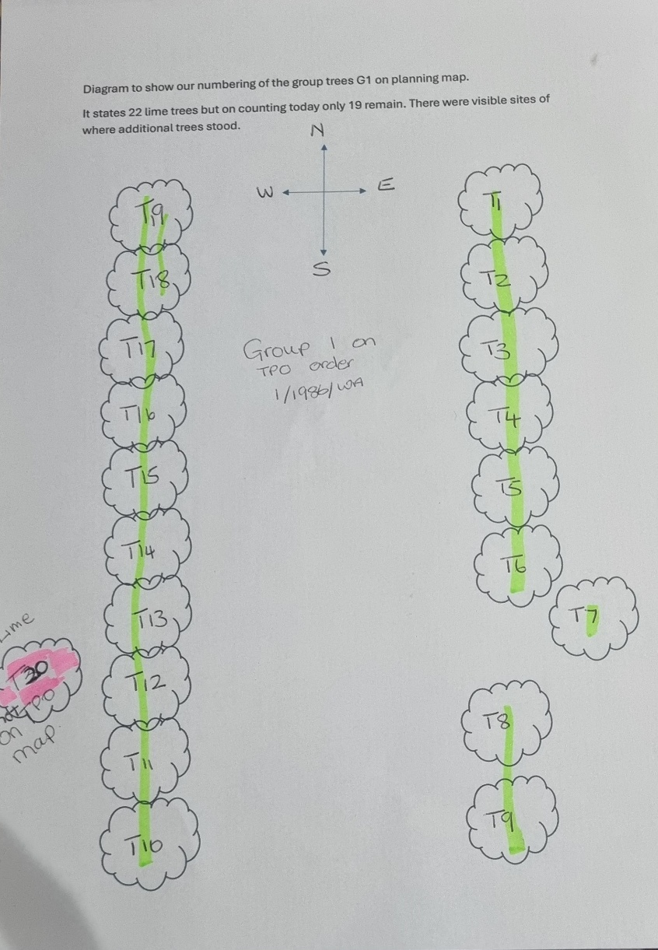
Lay out of trees and numbers
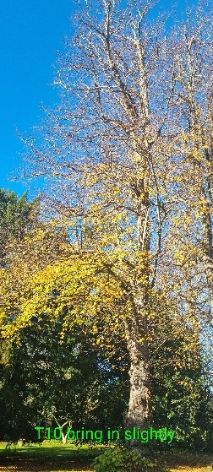
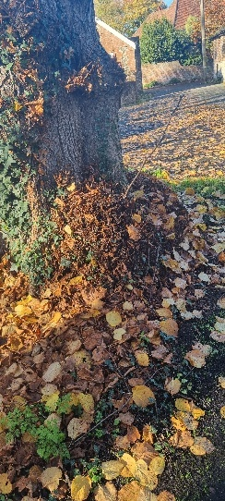
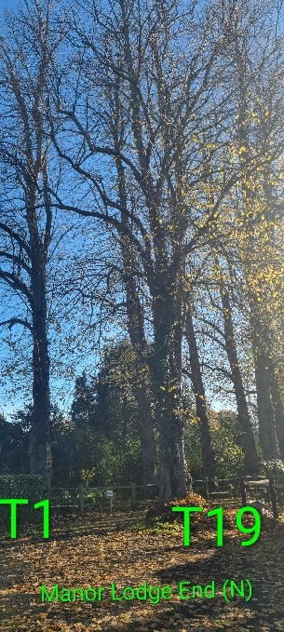
Example of basal growth
