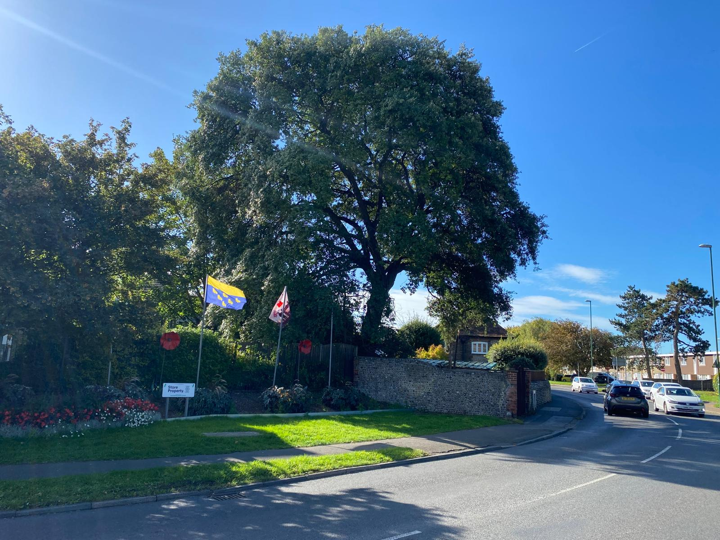
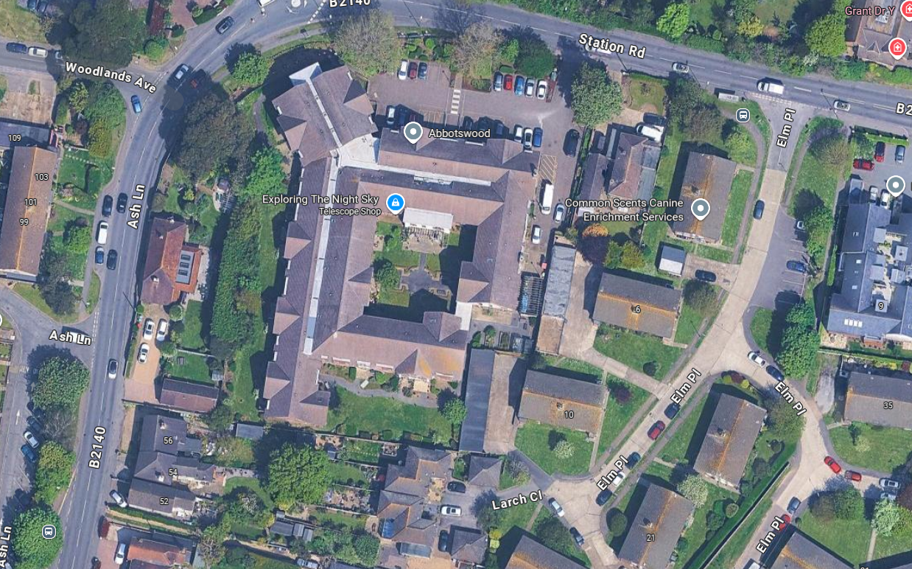
Tree stands approximately 17m tall with a crown width from centre of 8.5m North, 8m East, 7.5m South and 7.5m West.
After the requested works, there would be a residual height of 15m and a crown width of 6 to 6.5m, growth point dependant.
Works, for the most part, are for general upkeep and maintenance to the tree but the client has also had complaints from neighbouring property about low and broken branches and debris falling.
Reducing the tree would help lower the concerns from neighbours whilst maintaining the tree at a reasonable size for the location.
Works would not be detrimental nor would it affect the amenity value of the tree.
North
Not to scale
Holm Oak

