Planning Statement in Support of a Full Plans Application

Proposed Single Storey Rear Extension with Skylight and Garage Conversion To;
5 Downlands Close, Pagham, West Sussex, PO21 3QA for
Mr. & Mrs. Leadston

This planning statement is submitted in support of a Full Plans Application
relating to proposed operational development at the above address.

Photograph 1 shows the front of the property (West Elevation) and location of the front of the garage conversion.

Photograph 2 shows the proposed location for the rear extension (East elevation) to the existing property.

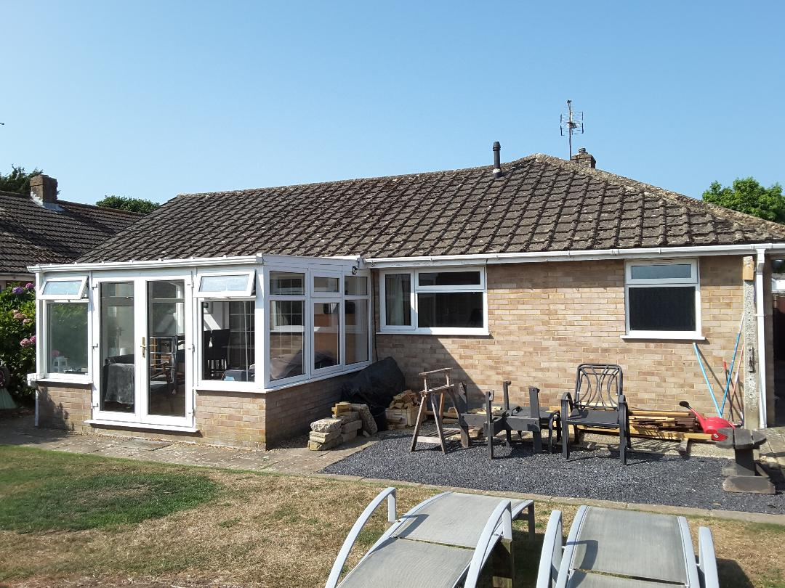

Rear Extension
A new rear extension shall provide an enlarged kitchen/lounge area.
The rear extension shall have a footprint of 7735mm x 3000mm. It will have an insulated cavity wall construction, finished with matching facing brickwork, with an insulated flat roof with skylight and insulated solid floor.
Existing foul drainage is to be extended across to the new kitchen area. Surface water is to be discharged via existing storm drains or a soakaway sited in the rear garden.

Garage Conversion
The new garage conversion shall provide a new office & dressing room/wardrobe area.
The existing garage front door shall be removed and be replaced with a window and cavity brickwork below.
The existing solid brick walls shall be clad internally with a dpm and an insulated stud wall. The ceiling will be replaced with new plasterboard and insulated as required.
The existing concrete floor shall be insulated & raised to meet that of the house finished floor level.
The rear door will be removed and a window installed.
Access to the garage will be via a new opening from the current bedroom 2.

Attachments:
We attach the following documents to this application:
- Existing Elevations
- Proposed Elevations
- Existing Floor Plans
- Proposed Floor Plans
- Block and Location Plans
- Site Plan
- Planning statement
- C.I.L. form
- Section drawings
- Garage floorplan

