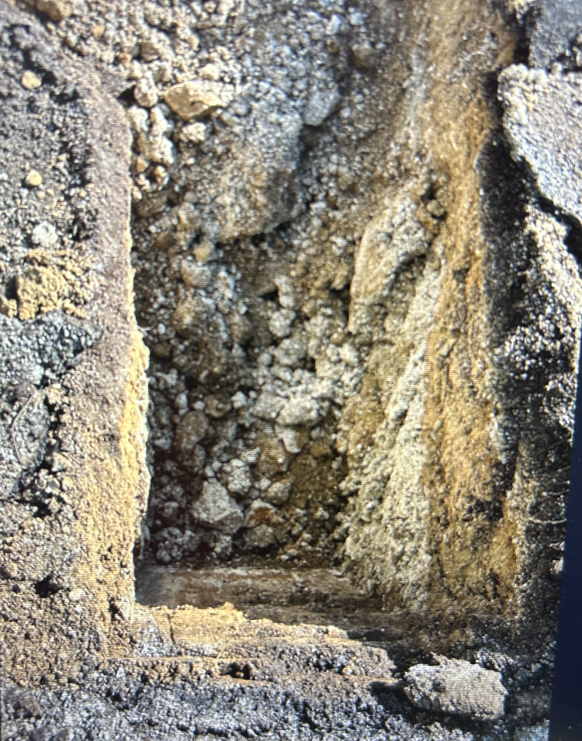
Photograph 1: Base of 1.3 m trial pit in Remediation Area A (5 August 2025)
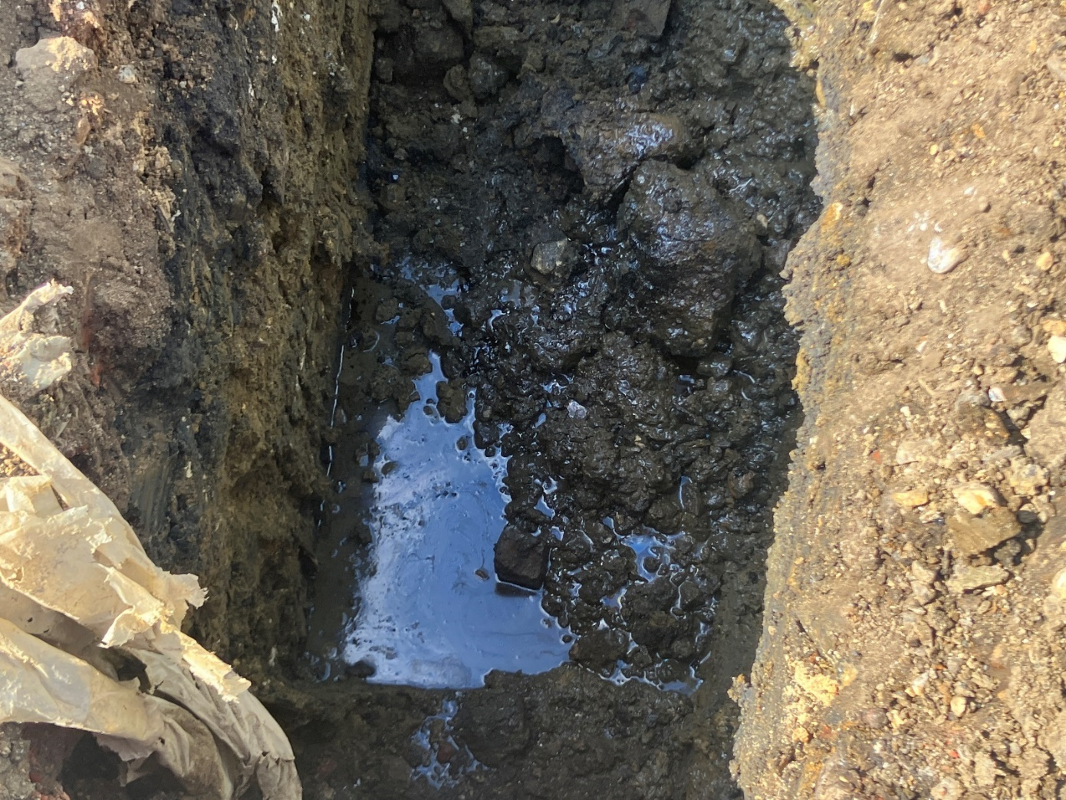
Photograph 2: Base of 1.4 m trial pit in Remediation Area B (5 August 2025)
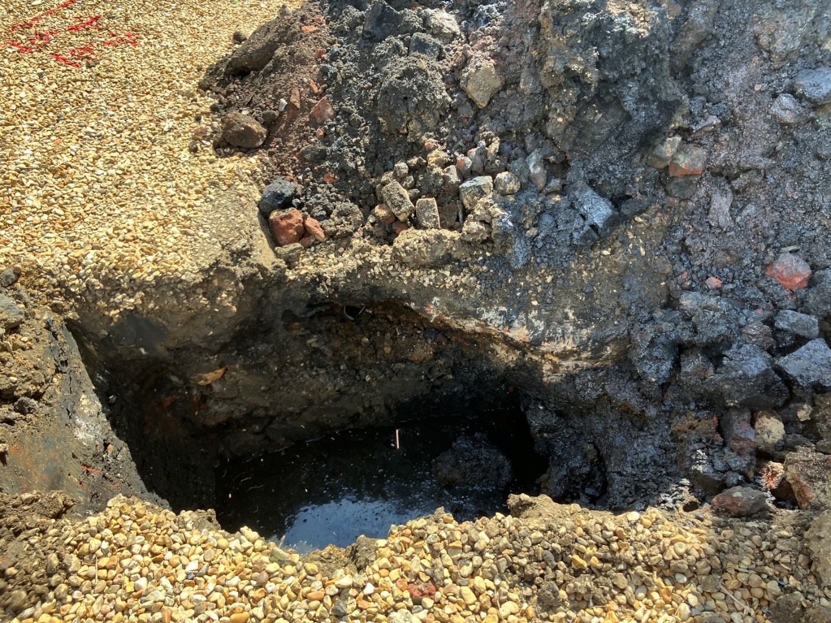
Photograph 3: Base of 1.8 m trial pit in Remediation Area C (5 August 2025)
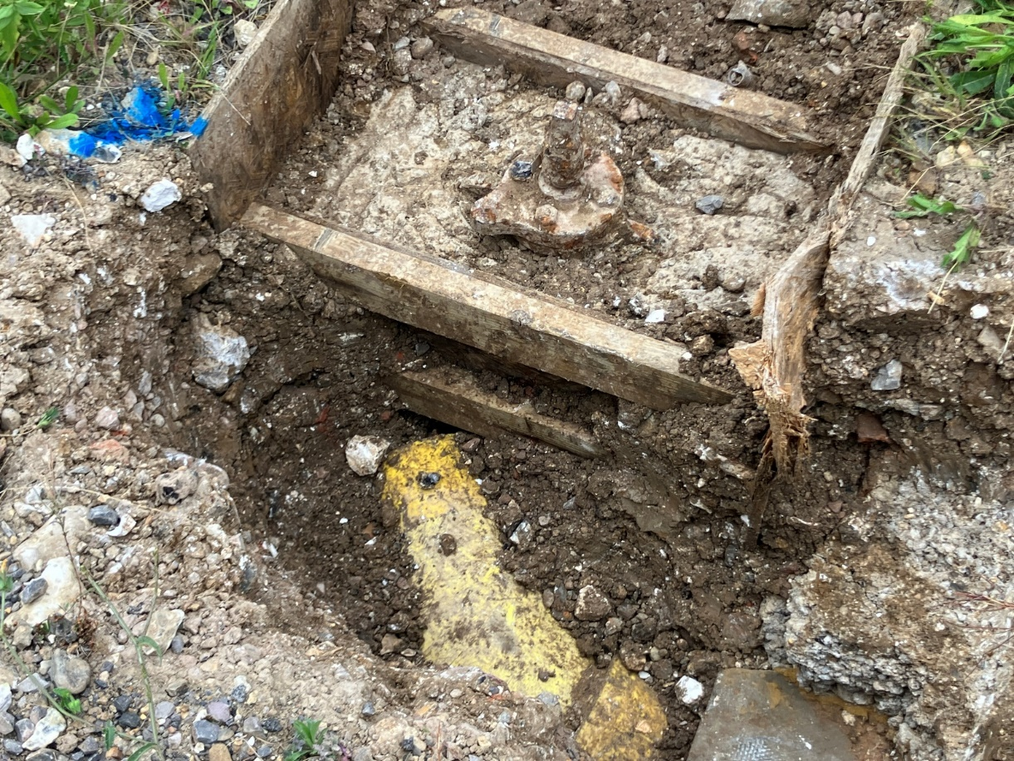
Photograph 4: Vacuum excavation pit No. 2 (as seen on site layout). (13 August 2025)

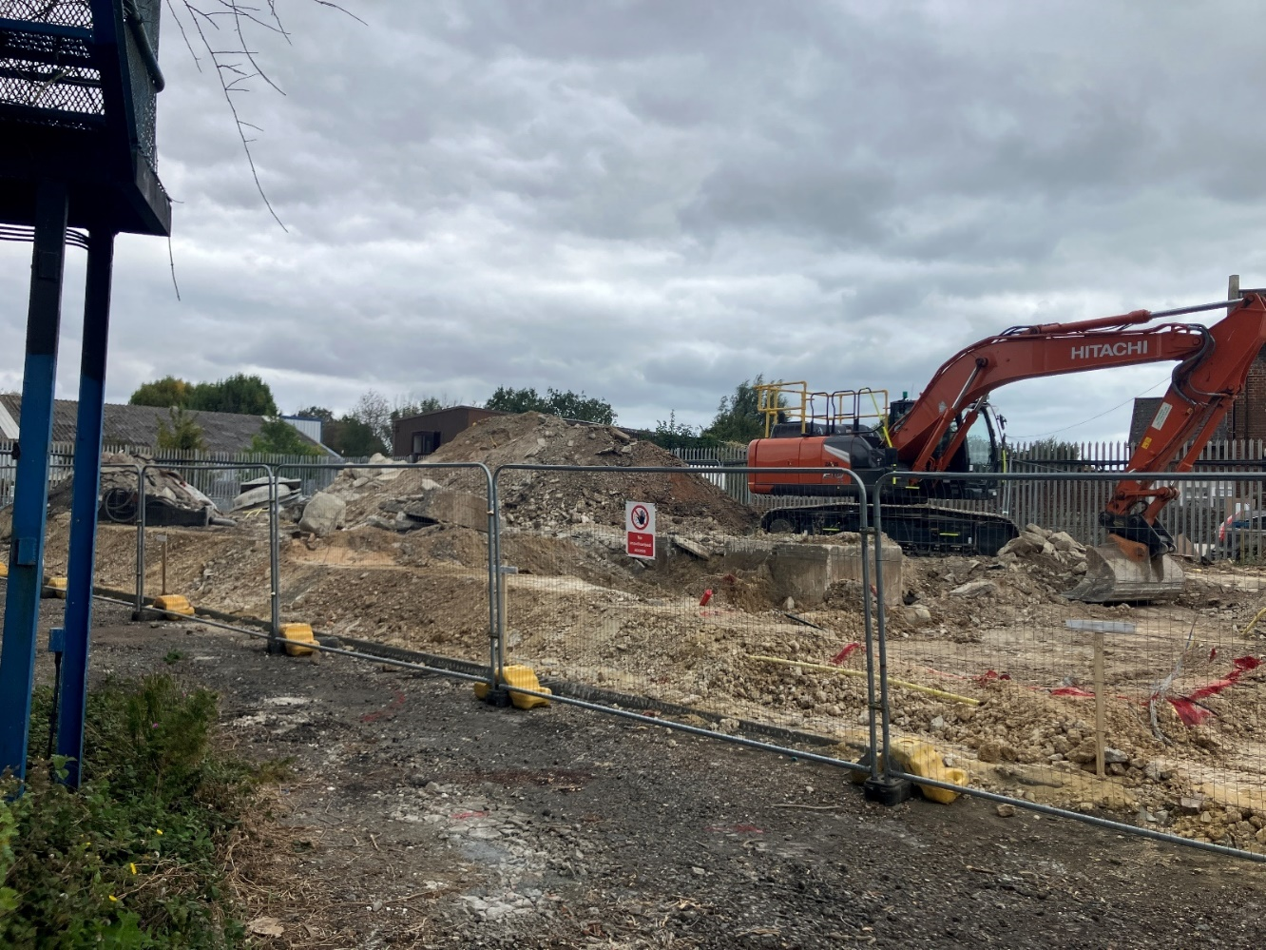
Photograph 5: Excavating Remediation Area A. Facing east. (20 August 2025)
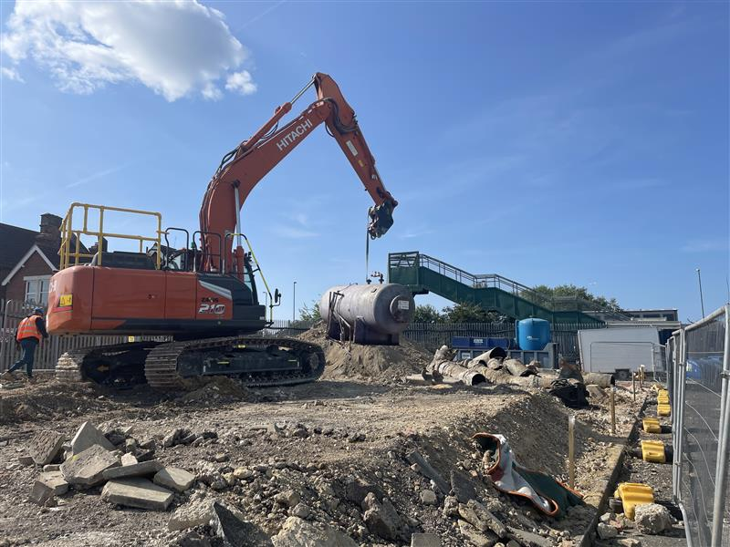
Photograph 6: Removal of redundant MEG tank. Placed with excavated gas pipes ready for removal. (22 August 2025)
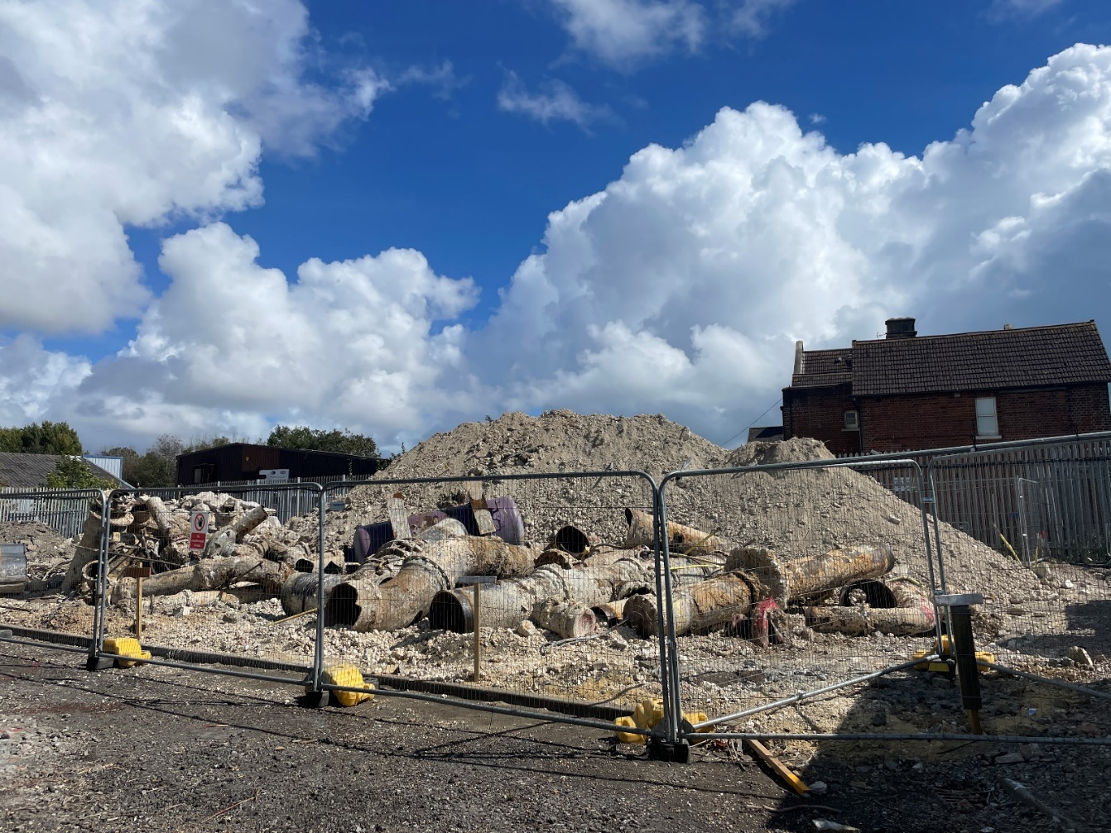
Photograph 7: Soil arisings to be exported stockpiled in southwest of Remediation Area A. Aspect southeast. (28 August 2025)
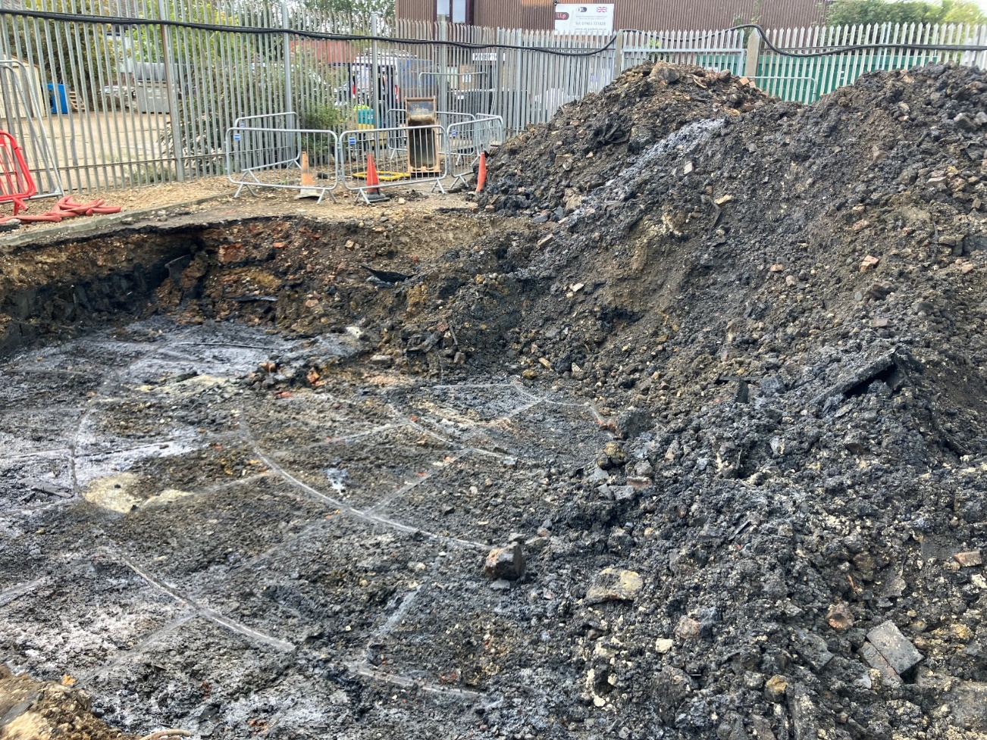
Photograph 8: Base of tank in Remediation Area B. Facing south. (1 September 2025)

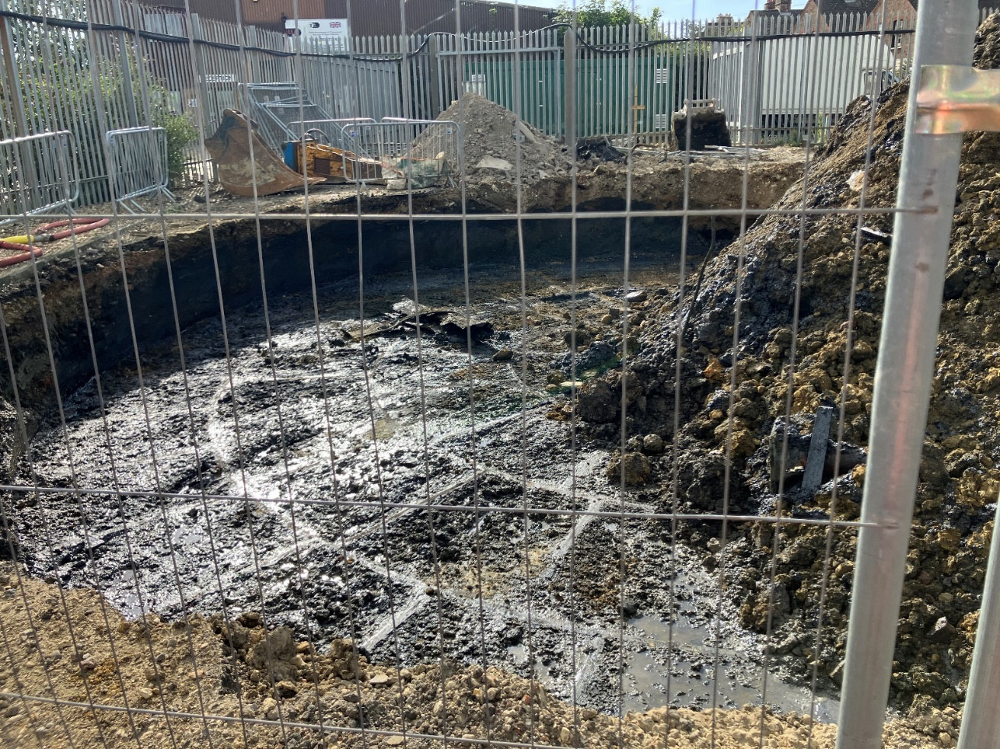
Photograph 9: Eastern portion of tank in Remediation Area B following export of material. Facing south. (9 September 2025)
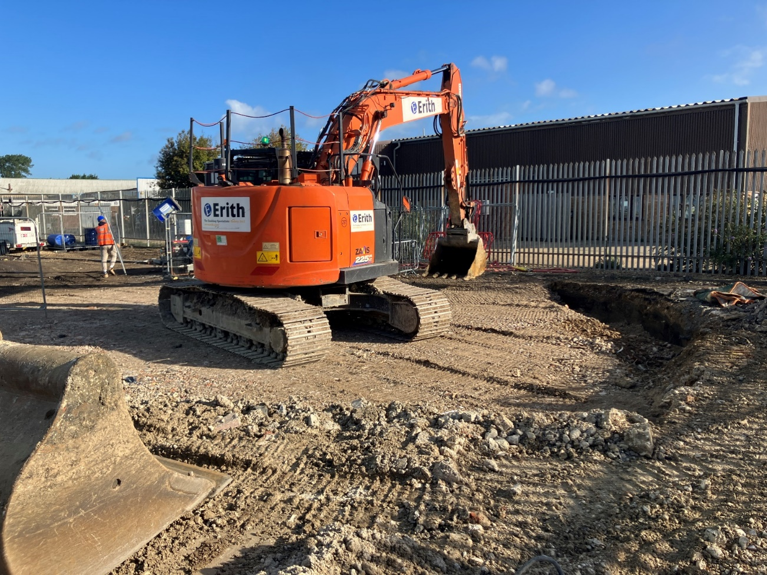
Photograph 10: Remediation Area B at end of week. Facing north-east. (12 September 2025)
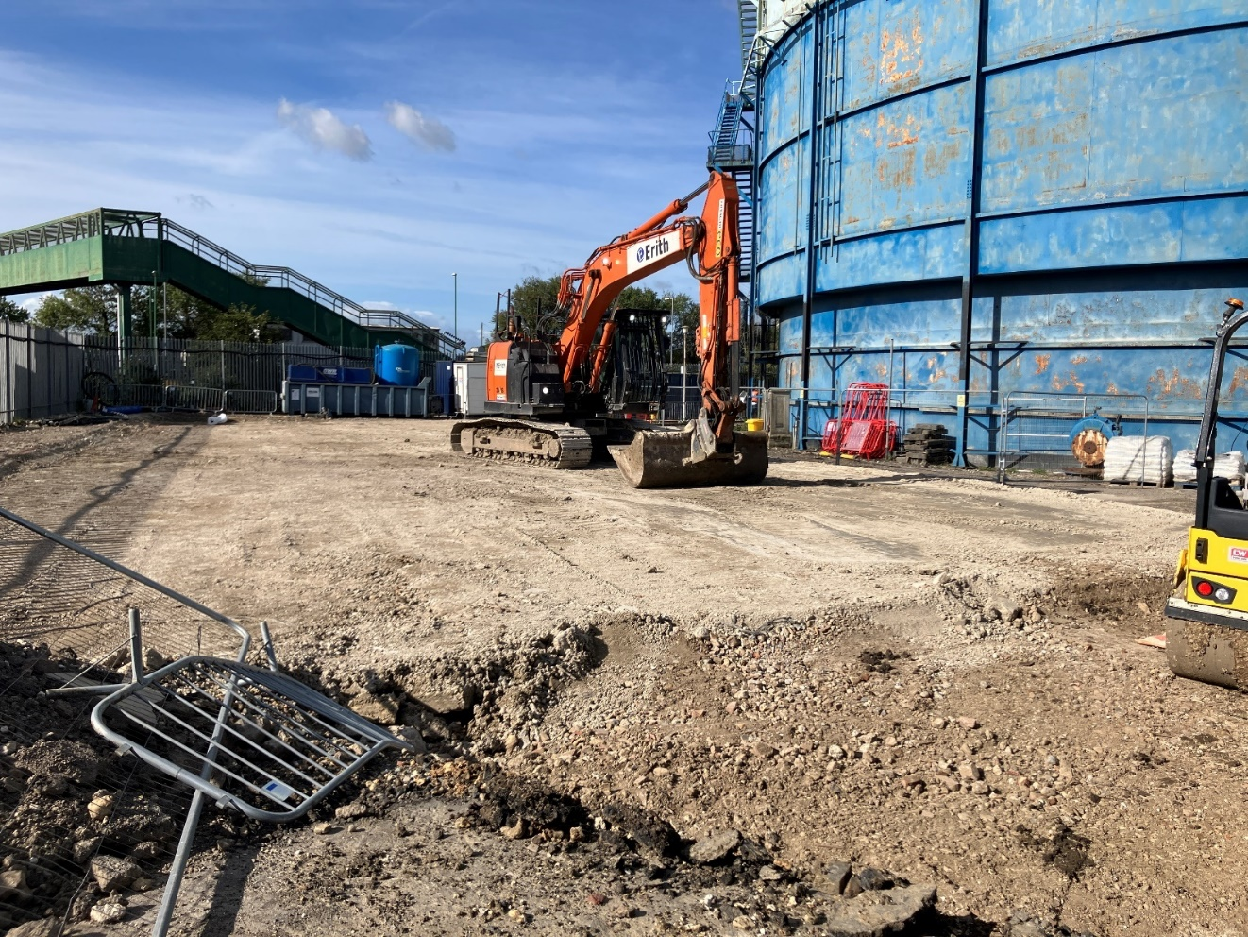
Photograph 11: Final regrading of Remediation Area A. Facing south-west. (16 September 2025)
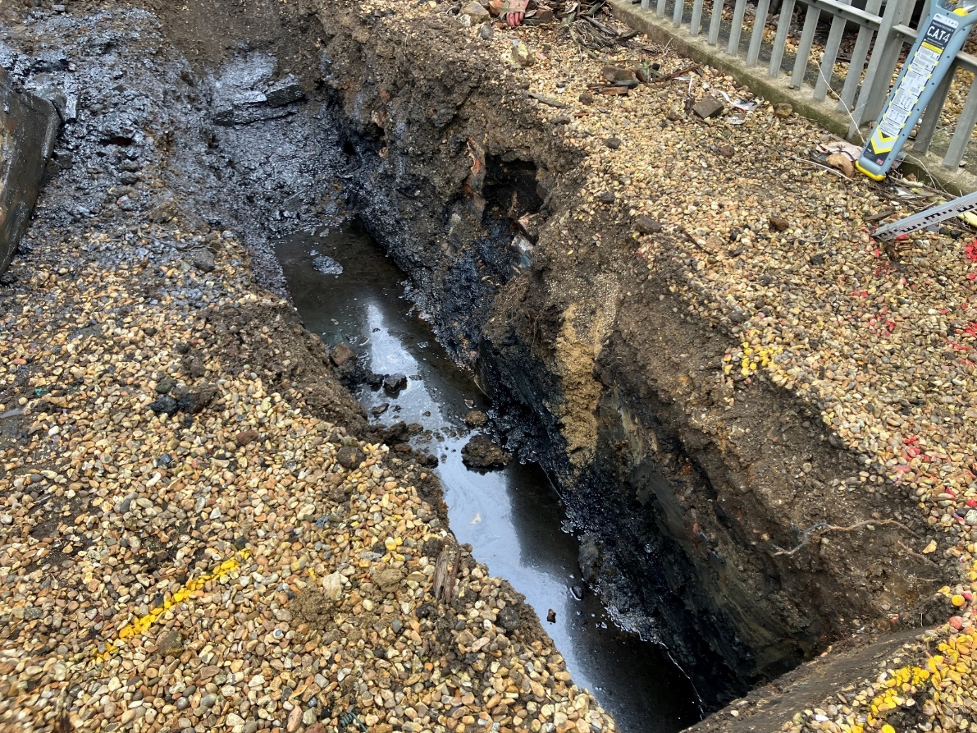
Photograph 12: North-western portion of Remediation Area C excavation to be infilled with clay to create cut off wall. (17 September 2025)

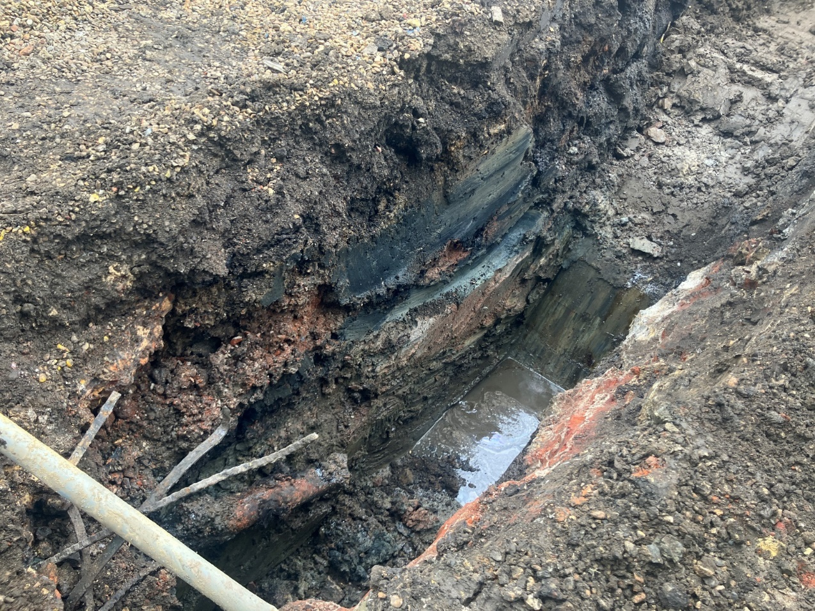
Photograph 13: Excavation extents to 2.5 m in the north-western portion of Remediation Area C. (17 September 2025)
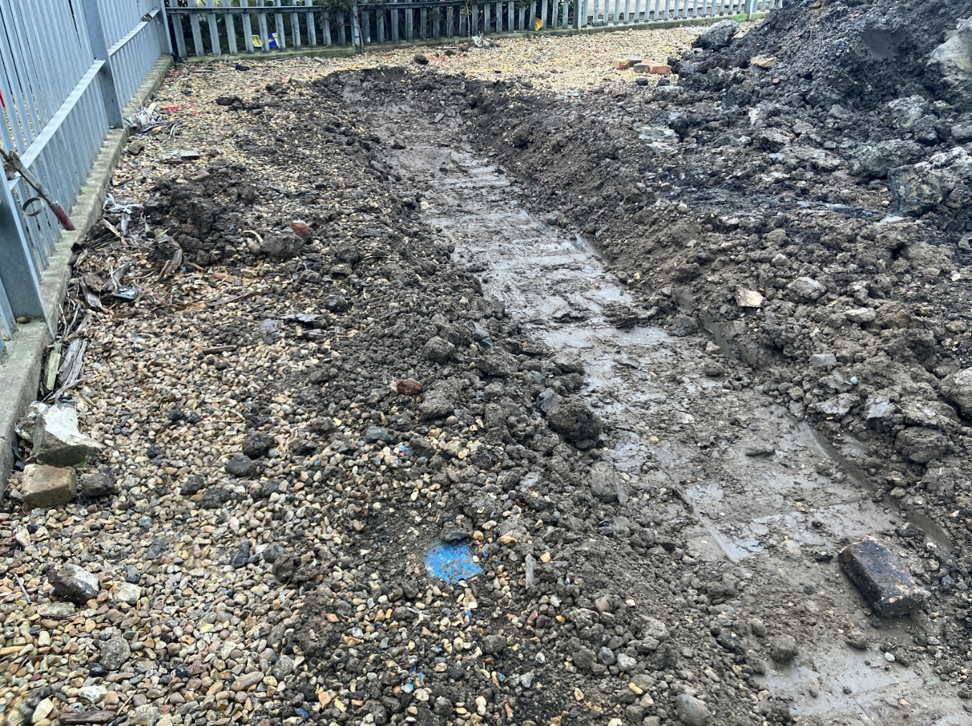
Photograph 14: Clay wall infilling excavation to 2.5 m in the north-western portion of Remediation Area C. Facing east. (17 September 2025)
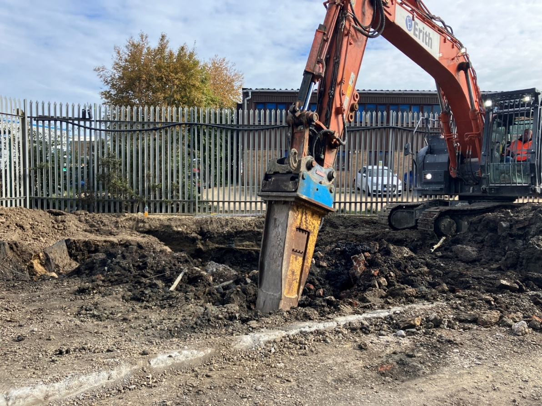
Photograph 15: Breakout of concrete and brick material from base of Remediation Area C. Facing north-east. (23 September 2025)
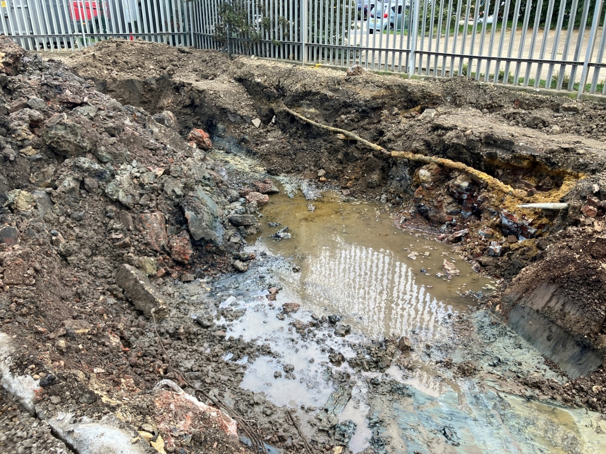
Photograph 16: Remediation Area C excavation. Facing north. (24 September 2025)

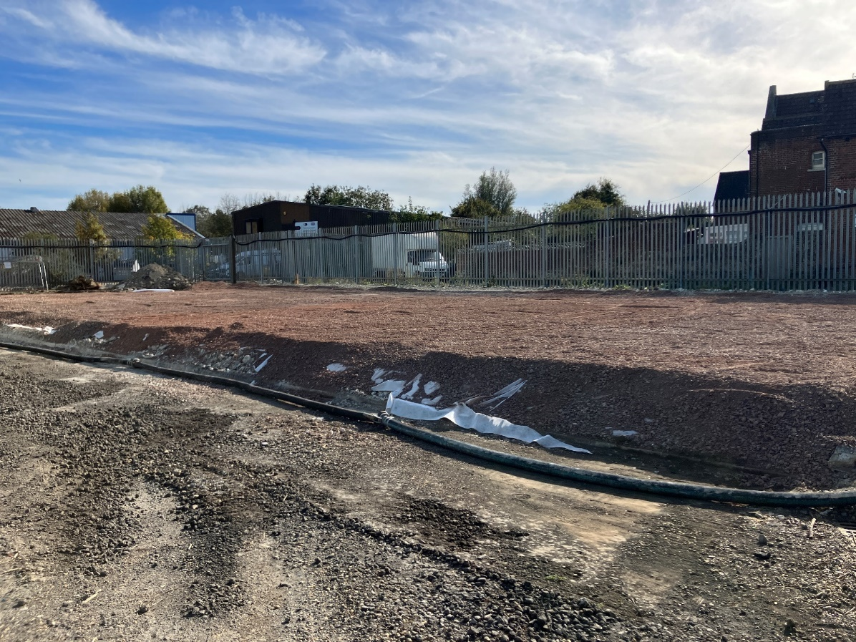
Photograph 17: Majority of Remediation Area A with geotextile membrane and 0.15 m of imported Type 1 placed atop. (25 September 2025)
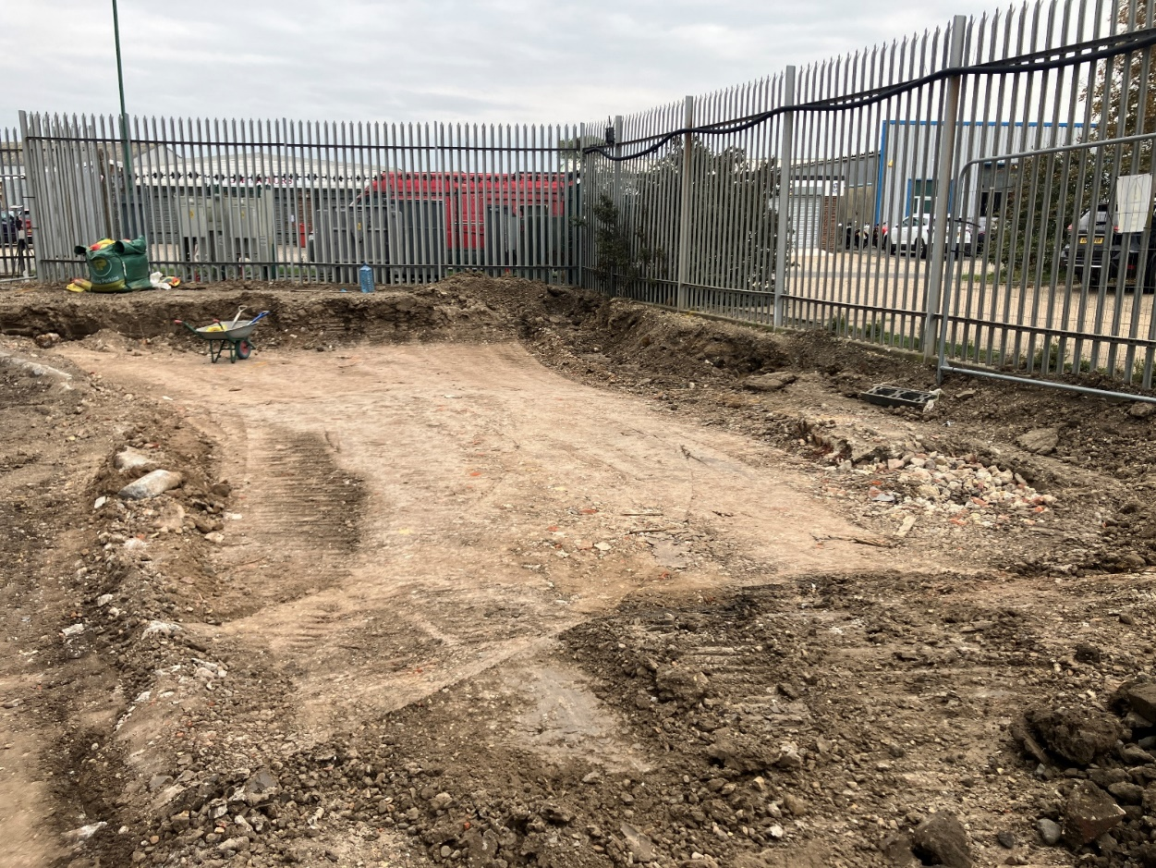
Photograph 18: Remediation Area C infilled and compacted with imported 6F5 material. Facing north. (26 September 2025)
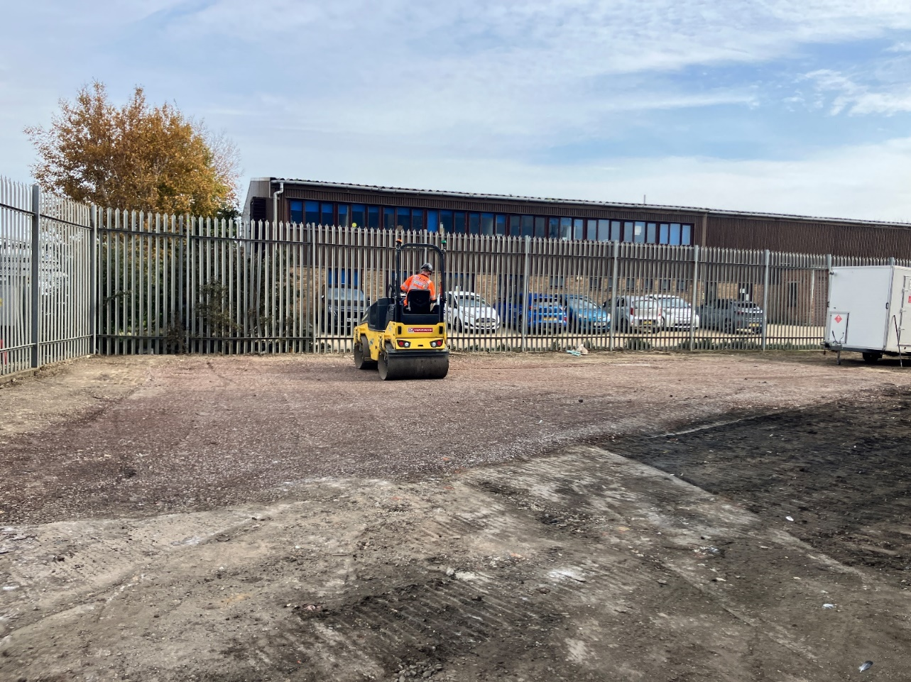
Photograph 19: Compacting Remediation Area C with twin drum roller. Facing east. (2 October 2025)
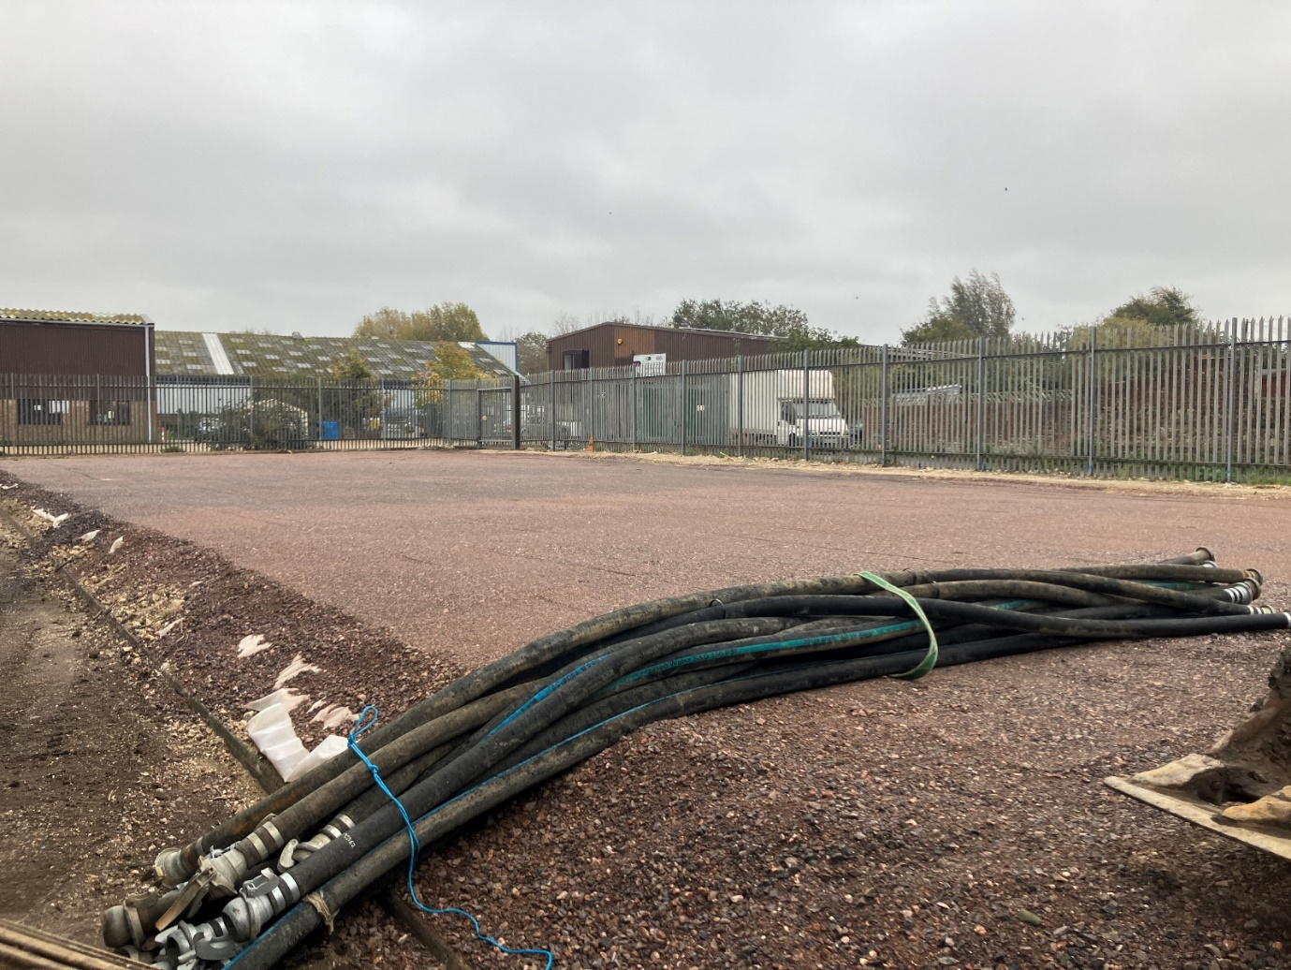
Photograph 20: Completed Remediation Area A. Facing east. (3 October 2025)
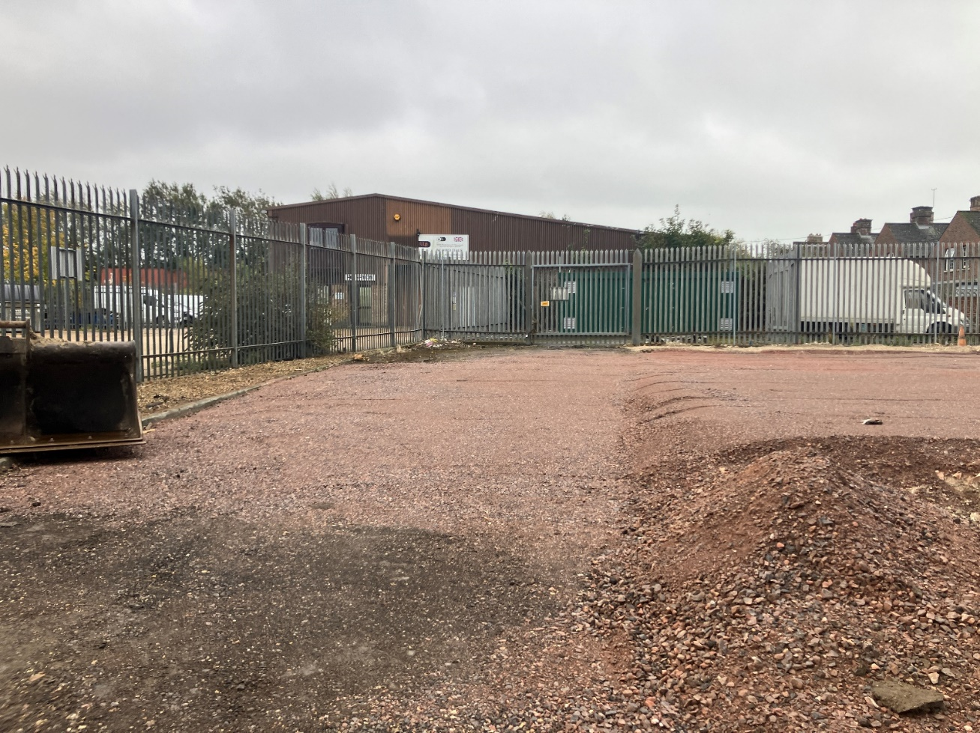
Photograph 21: Completed Remediation Area B. Facing south-east. (3 October 2025)
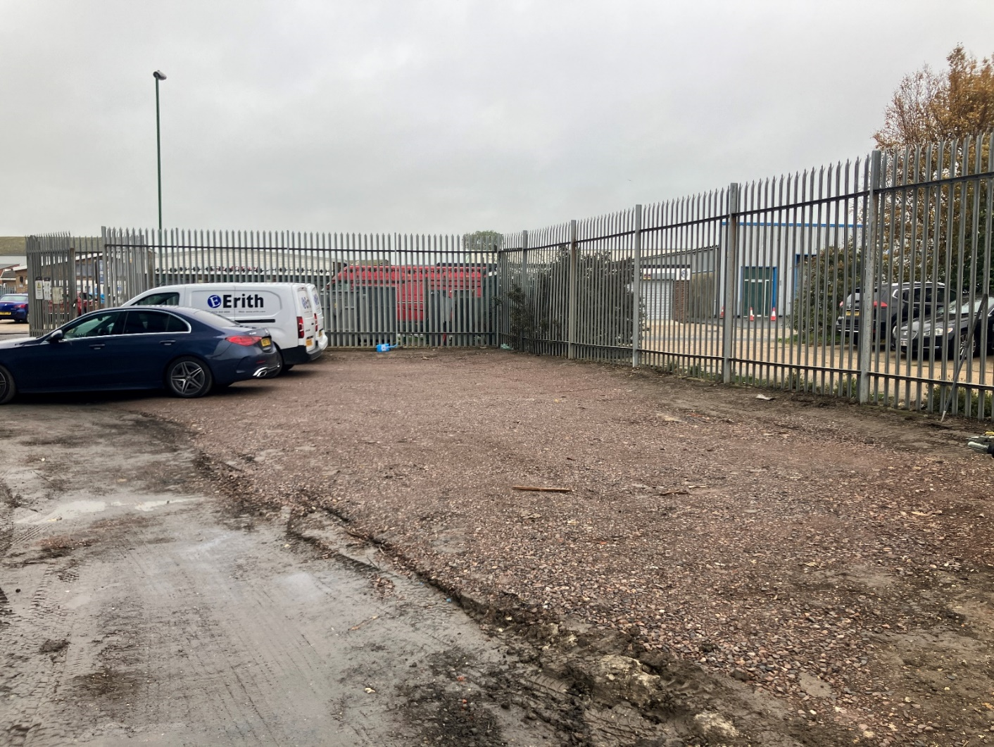
Photograph 22: Completed Remediation Area C. Facing north-west. (3 October 2025)

