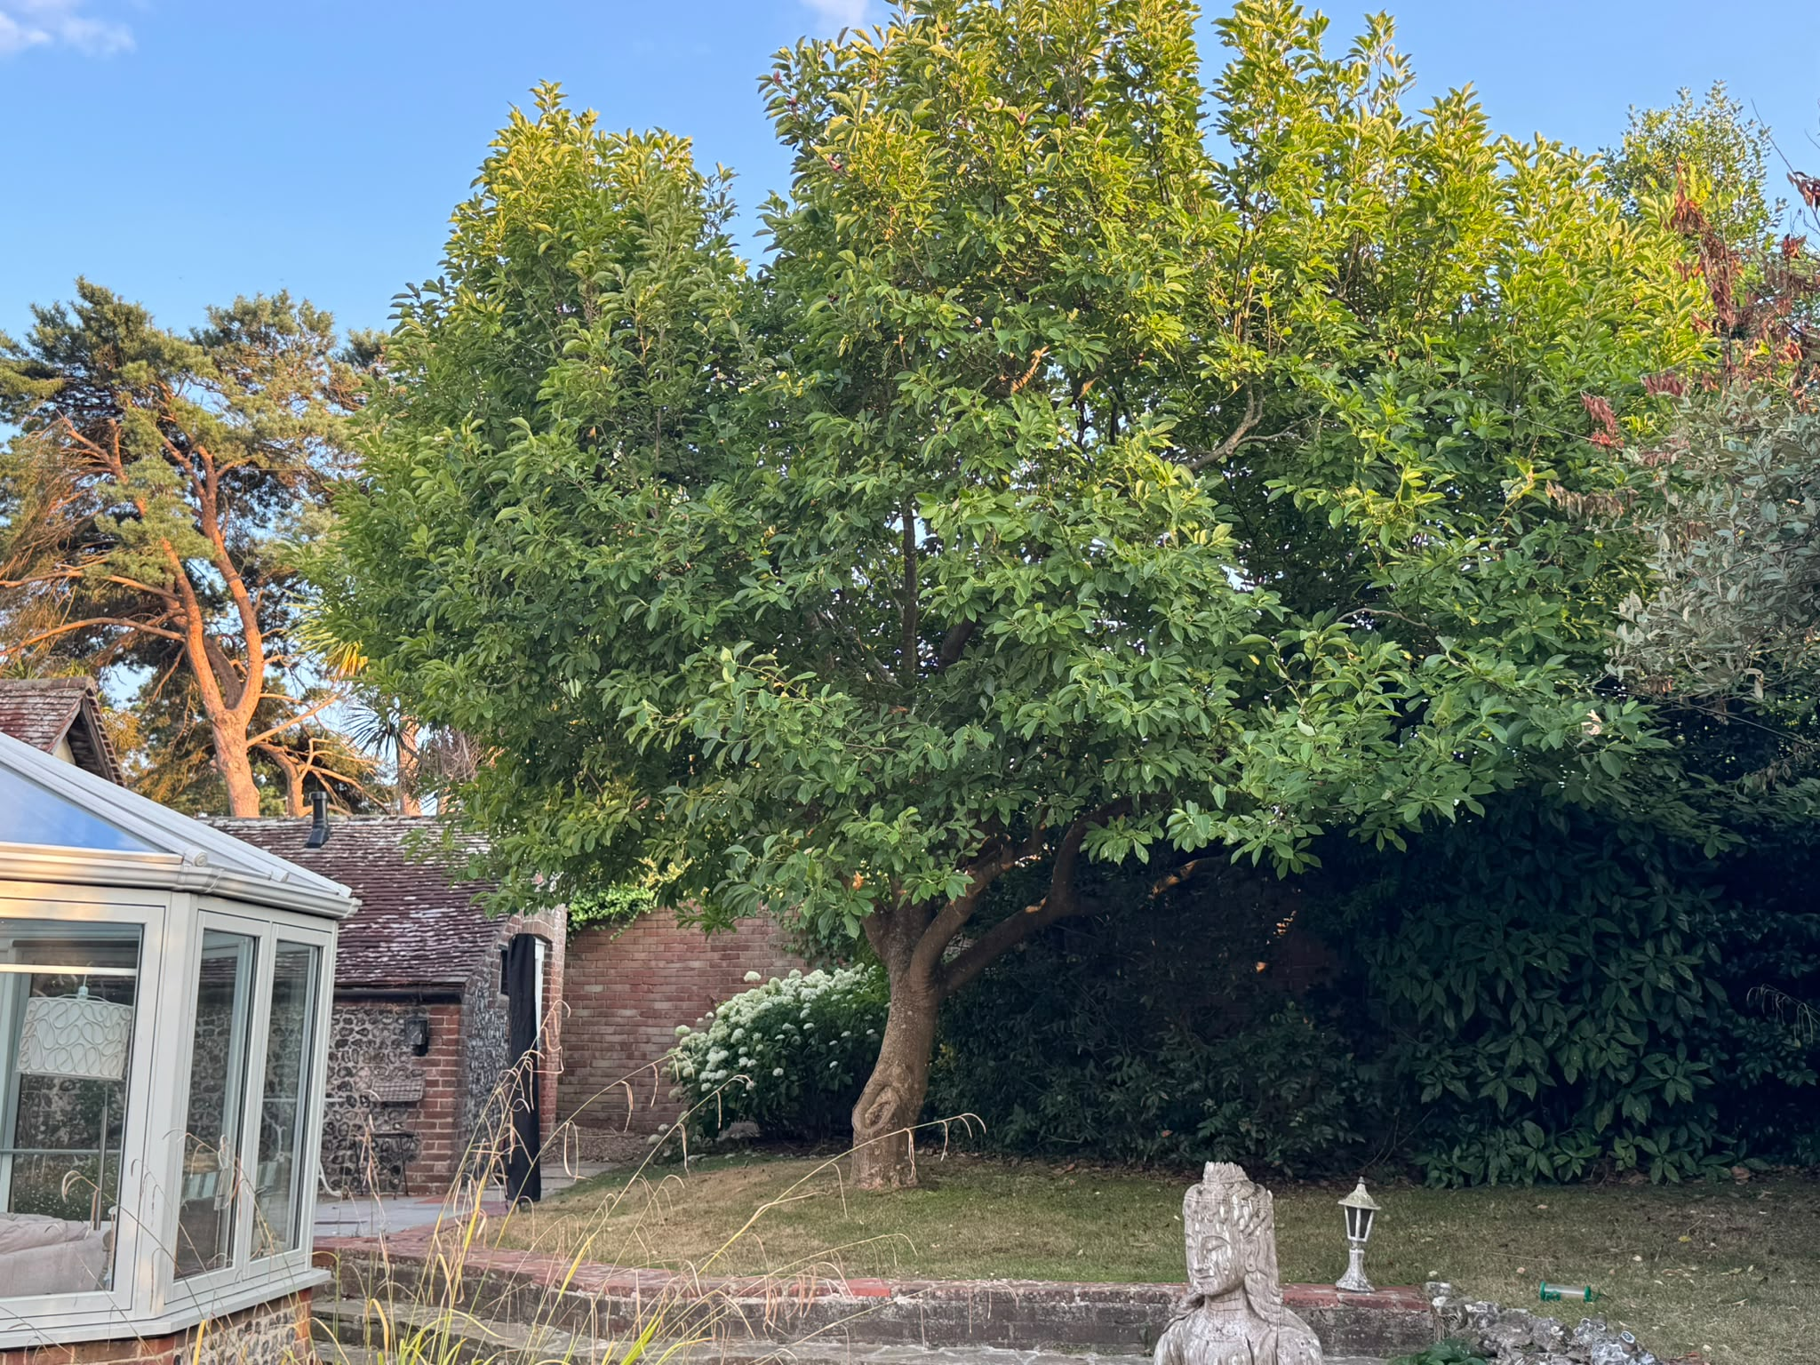
Figure 1 T1 Magnolia
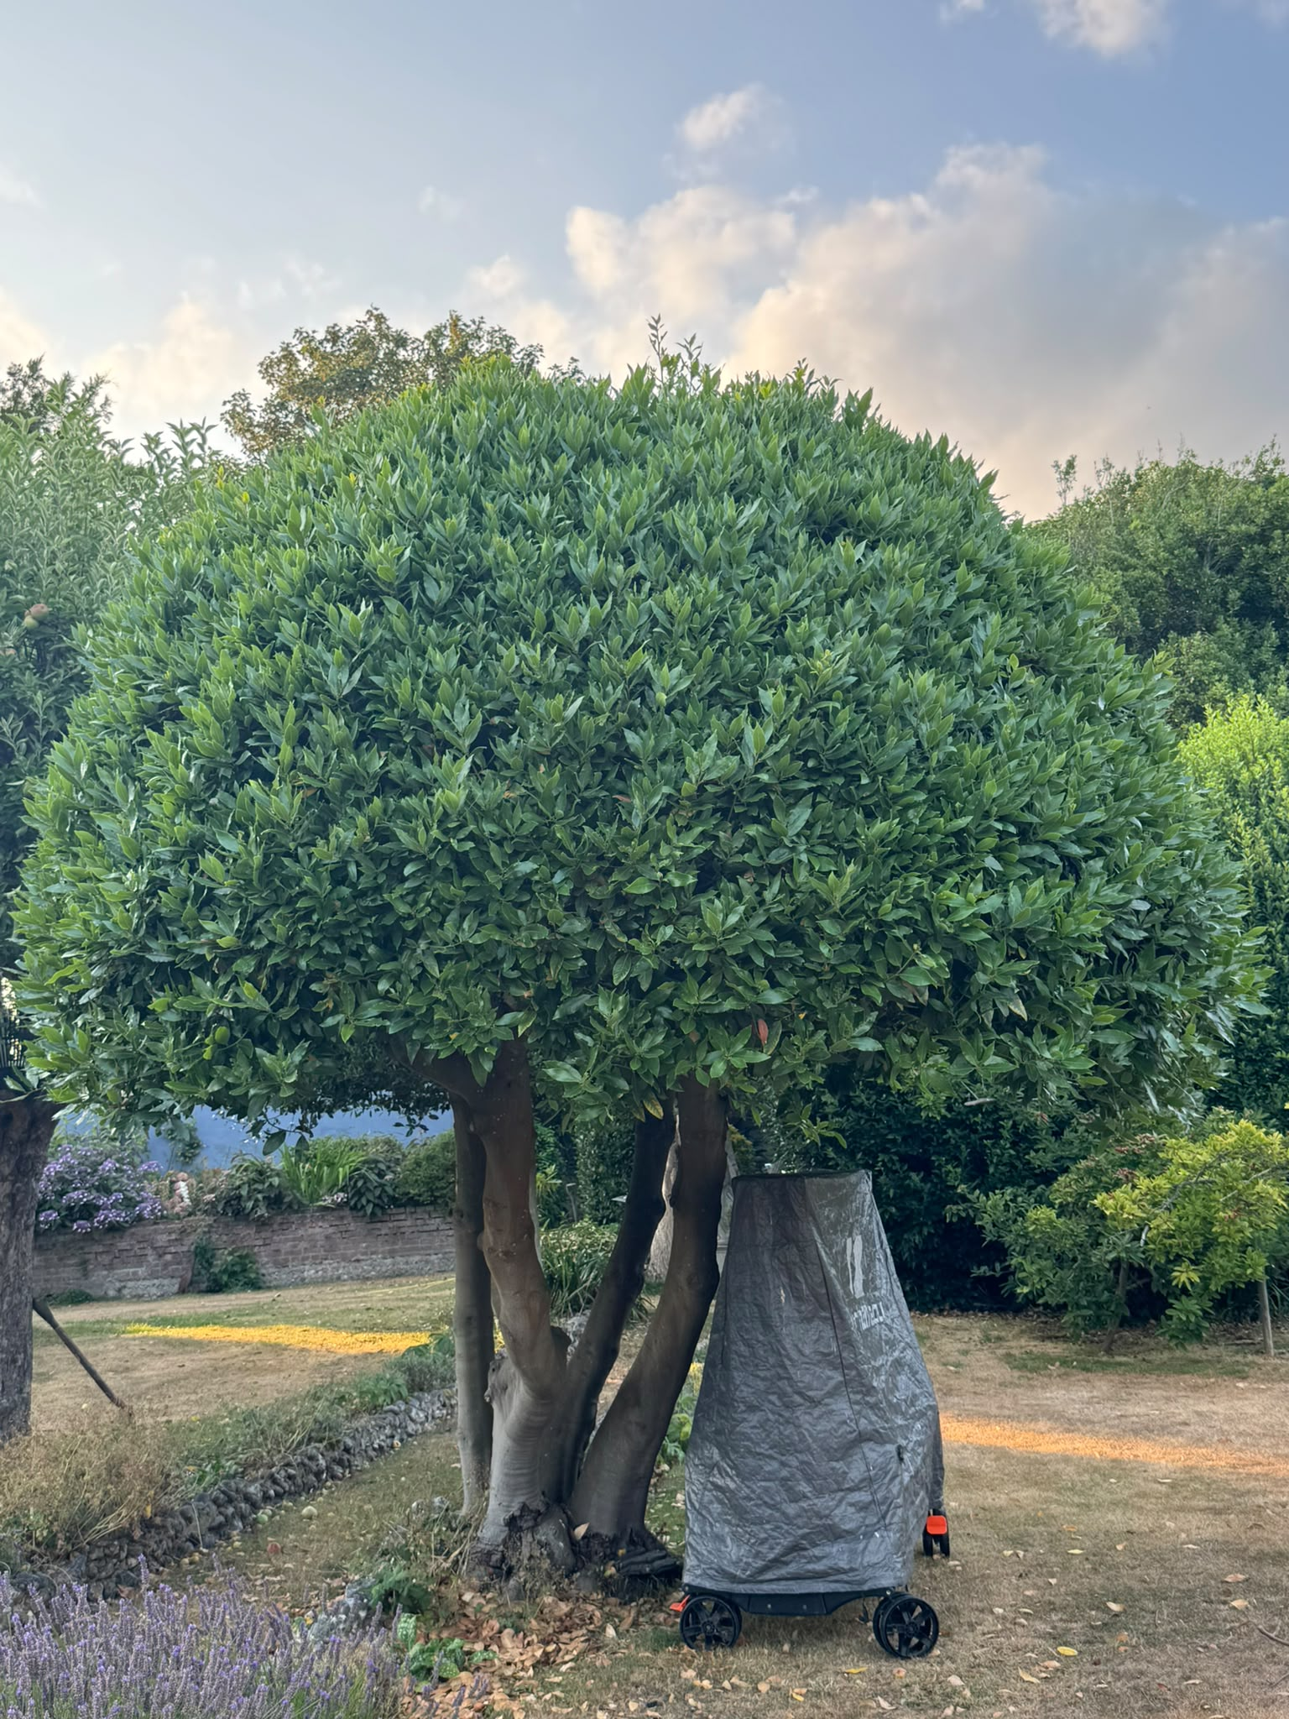
Figure 2 T2 Bay tree

