FLOOD RISK ASSESSMENT

OUR REFERENCE 90018638

PROPERTY ADDRESS KINGARTH LAKE LANE, BARNHAM BOGNOR REGIS , WEST SUSSEX PO22 0JA
PROPOSED DEVELOPMENT
Installation of Conservatory to north eastern elevation of property
FLOOD RISK ASSESSMENT
The location is in flood zone 2, an area with a medium
probability of flooding.
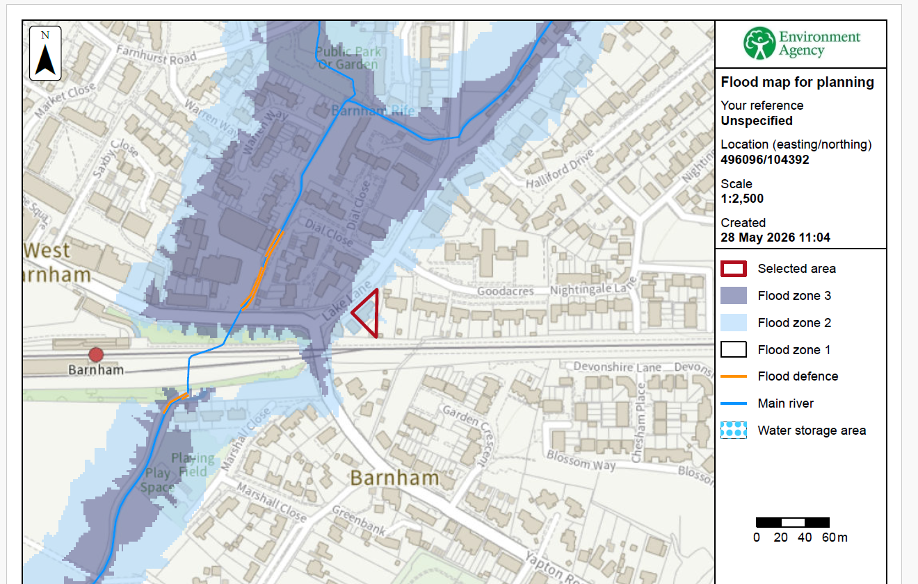
Please be advised that:
- The finished floor level of the proposed conservatory will remain the same as the existing house.

- The proposed conservatory is not to be used for storage and therefore there would be no loss should flooding ever occur. Additionally, any furniture positioned in the structure will be removable in the event of flooding.

- Our client should already be aware if ever any flood warnings should occur and therefore would move possessions that may be affected to a higher level to avoid damage.

- We will be using PVCu windows, doors and frames and special care will be taken to ensure adequate sealing of PVCu windows and doors to the fabric and double glazing will be to the relevant standards.

- All electrical sockets and switches, if applicable, will be positioned at level greater than at risk of flooding and will be fitted in compliance of current British standards.

Surface Water Drainage/Mitigation measures
Any rainwater drainage caused will be linked to the existing rainwater drainage and won’t cause any additional drainage onto any neighbouring properties.

