
COUNCIL CONSERVATION AREA APPLICATION

TYPE OF APPLICATION: CONSERVATION AREA
OUR WORKS REFERENCE: 89829
ADDRESS/LOCATION OF WORKS: Arundel Road, Angmering, BN16 4NQ
W3W: lifeboats.applause.retrain

DESCRIPTION OF WORKS:
Our company (Traffic Control 123 Ltd) work on behalf of Enerveo, clearing necessary street lights and signs of trees/foliage, so as to allow access for maintenance/repair, as well as to maintain public safety.
We have been instructed to clear lighting column number 2 along Arundel Road.
We need to clear the lighting column of foliage at a 60 degree angle from the head of the lamppost. Any foliage that falls in this zone, that is in line with, or in front of the column itself will need to be trimmed.
These works are required so that sufficient light is able to reach the road/footpath below, therefore maintain public safety at all times. The cutting also allows engineers to access the column to carry out repairs when necessary.
I have provided the following details along with site photos taken to highlight the works that are required.
I can see from the council map, the trees/bushes we are required to cut, are situated within a conservation area. I am therefore applying for permission to cut a small portion of these bushes/trees .
CONSERVATION AREA NUMBER/NUMBERS (IF KNOWN): ANGMERING
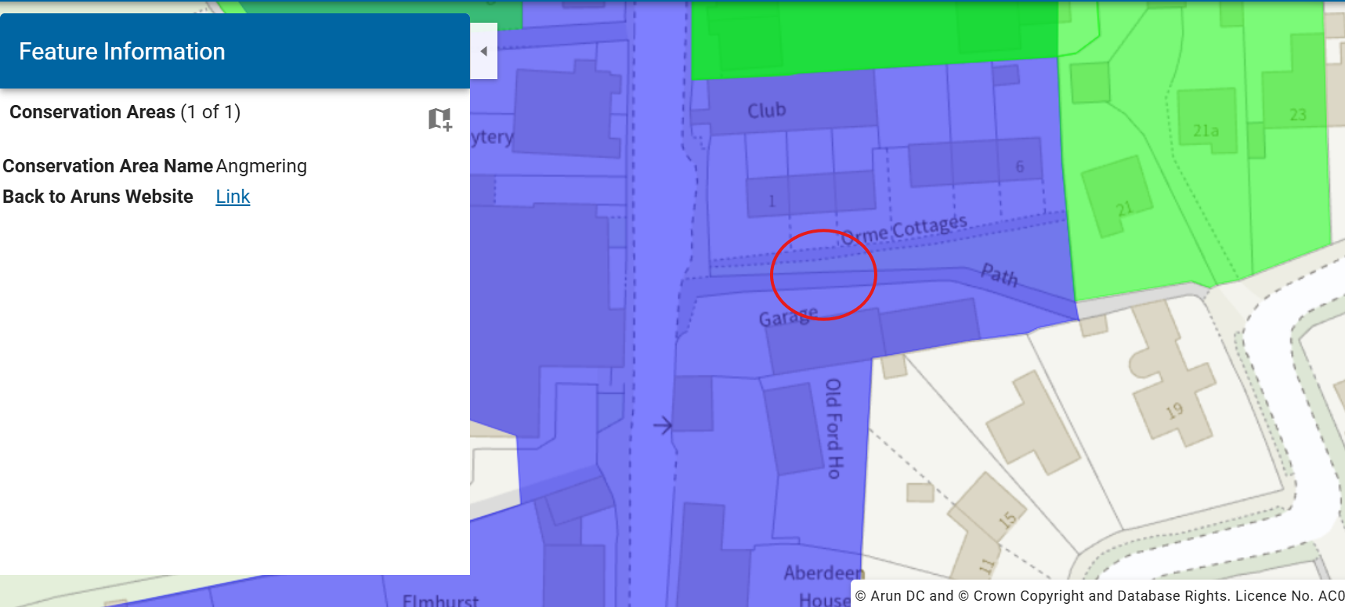

Cutting area highlighted in yellow below:
TREE SPECIED AFFECTED:
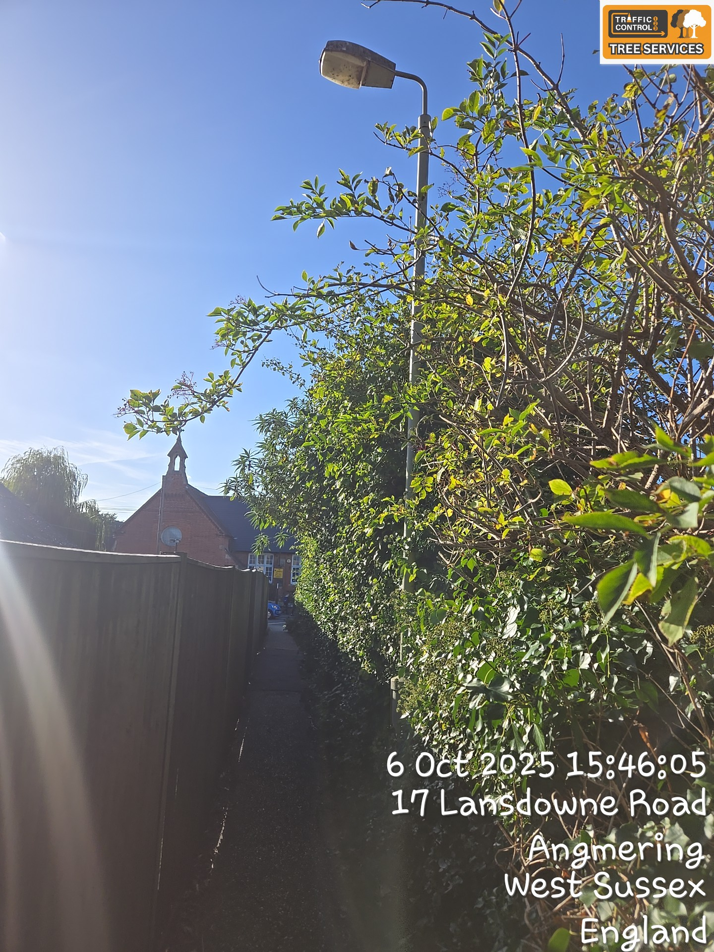
1 x Rhododendron, 1 x Common Lime

