S.91 Town and Country Planning Act 1990 states that the development must commence by the date given in the planning approval (i.e. on or before 09.06.2026 in the case of permission granted under AB/24/23/PL)

S.56 (2) Town and Country Planning Act 1990 sets out that what constitutes "commencement" is when a material operation has begun.

S.56 (4)(aa) Town and Country Planning Act 1990 then specifies "Any work of demolition of a building" as a material operation.

So, my understanding would be that to ensure that the planning does not lapse I just need to provide evidence to the council that the demolition has occurred and that it occurred before 9th June 2026 to ensure that planning does not lapse.

To that end I have already notified and provided evidence in the form of an email sent to the CIL Team informing them of the intention to start demolition works on 4th May 2024 as part of the CIL exemption application (please see 24.04.2024 email attached from the CIL Team confirming 4th May commencement date for demolition work) and the Building Control Team back in May 2024 (please see email attached from Building Control back in 20.05.2024, in which they acknowledged confirmation that the building had been demolished, which they confirmed with a personal visit too).

I also attach a photo of the site showing the building has been demolished, together with Google Arial view showing that the property is demolished:

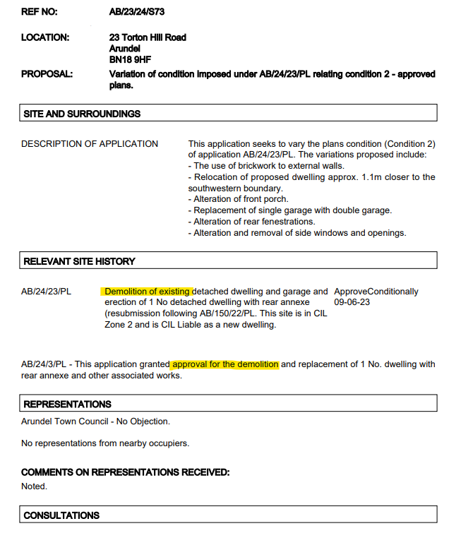
As the planning permission description explicitly includes the Demolition of the property, and that the demolition has occurred before the commencement date, that the Permission has in fact already been taken up, so cannot lapse.

Please confirm that the planning will exist in perpetuity?

