25 Surrey Street, Arundel, West Sussex, BN18 9DT
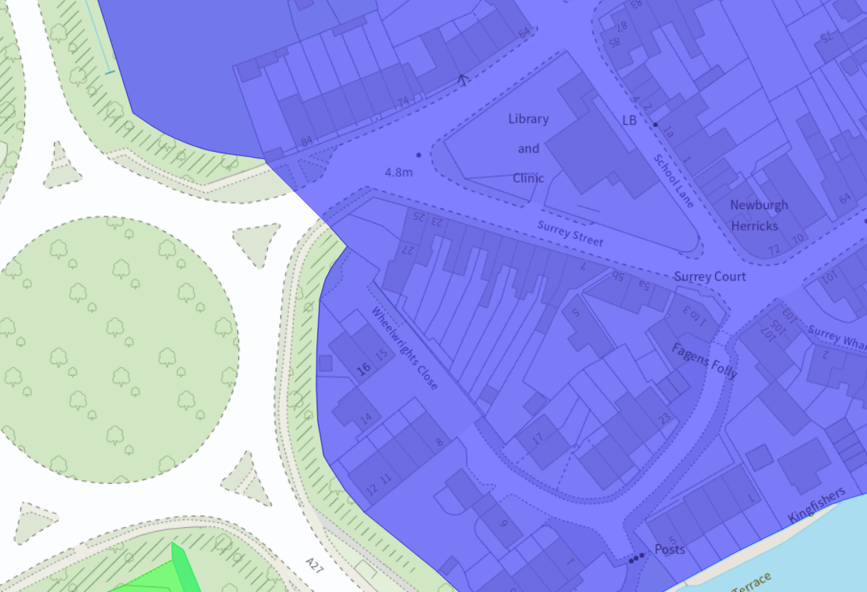
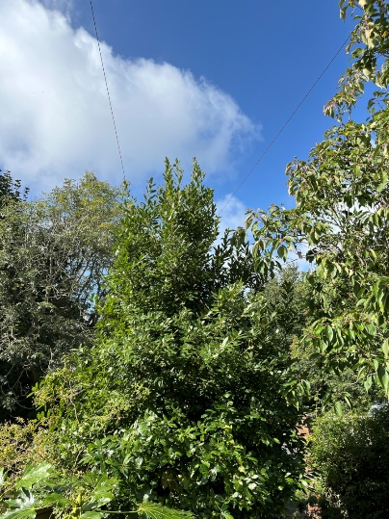
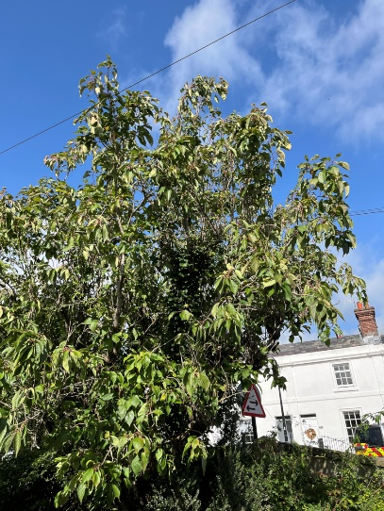
Reduce cherry trees back to previous points (1.5-2m), creating a nice shape. Reduce bay tree by 30% (1.5-2m), bringing the crown away from the cables. 